Nomogram distribution in the Amyloidosis Sampled Population Versus Not Sampled Population

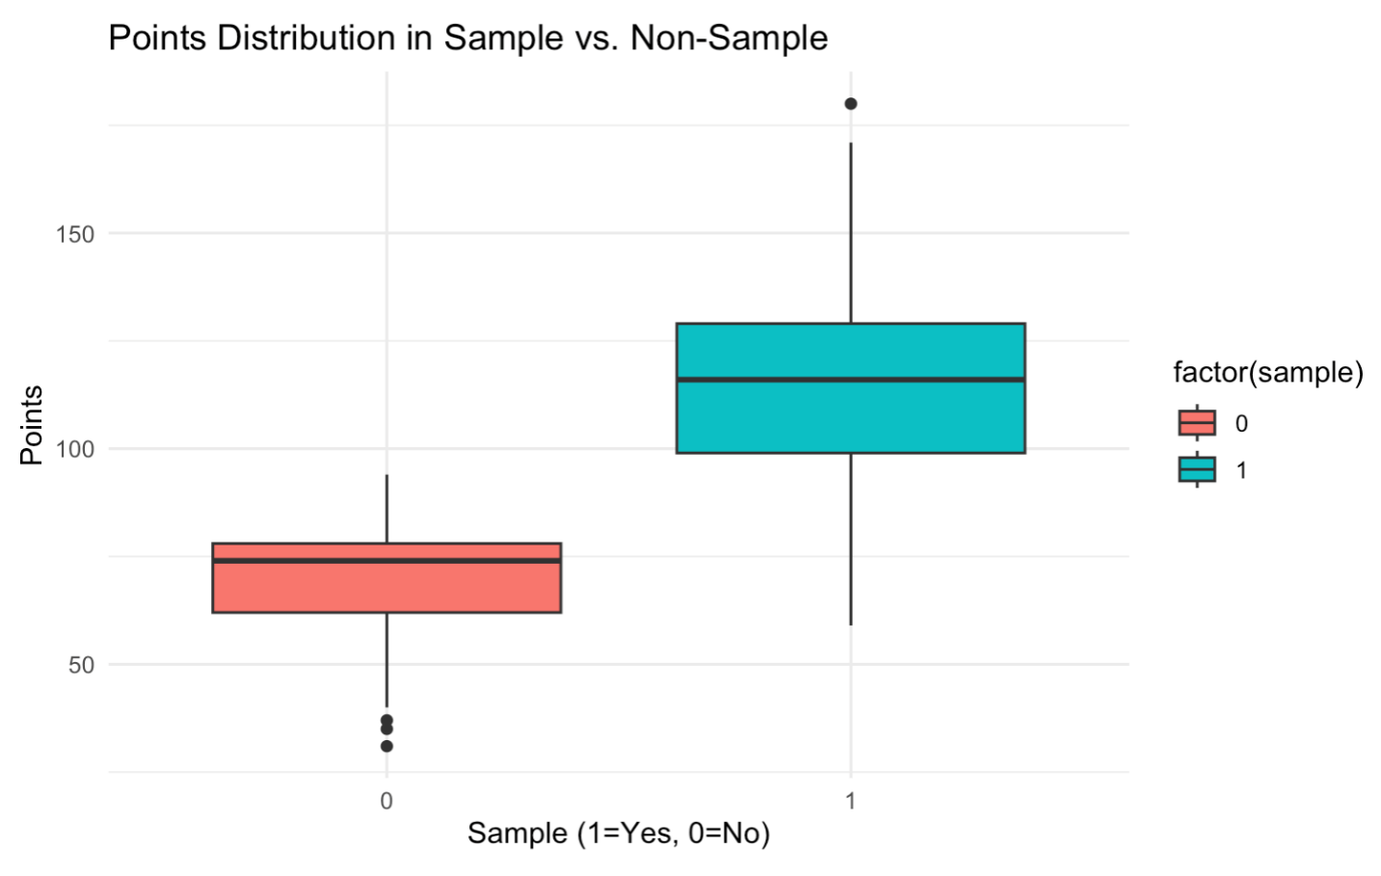

The box plot illustrates the distribution of Nomogram Points vs the sample indicator. The median nomogram points for the unsampled group is approximately 75, while the sampled group has a median above 100. This difference between the sampled versus unsampled groups suggests a potential selection bias, where the sampling process tends to select patients with higher nomogram points. As a result, the patients that were sampled may not be representative of the entire population that receives carpel tunnel surgery.

Inverse Probability Weighting to Address Selection Bias:

To address selection bias, we conduct further analysis using Inverse Probability Weighting to assess whether corrections are necessary. The concept involves assigning a weight to each observation, calculated as the inverse of the selection probability conditioned on the Nomogram score. The selection probability here refers to the probability of each observation being sampled for Amyloidosis given their Nomogram score. The weighting adjustment for each observation of the sample may better reflect the target population, which in this case are the patients with carpal tunnel syndrome who received surgery. To estimate the selection probability, a logistic regression is fitted using the sample indicator as the response variable and nomogram points as the independent variable.

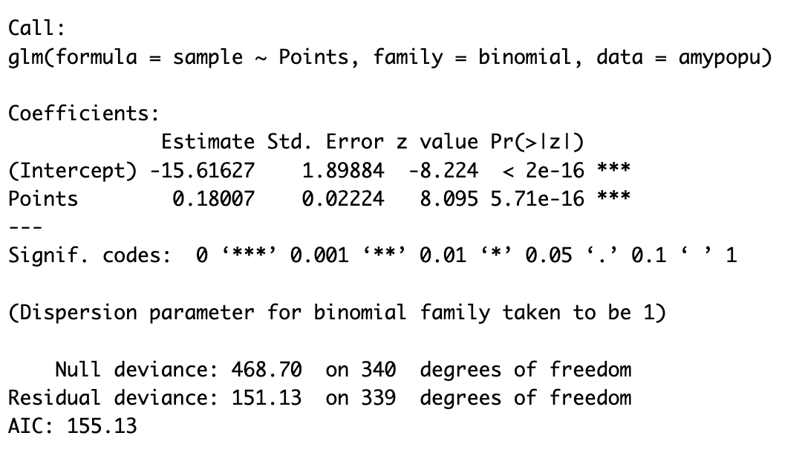

If an observation had a low probability of being sampled, its weight is high. If an observation had a high probability of being sampled, its weight is low. This ensures that underrepresented observations receive greater influence in the final model.

Modeling Amyloidosis in the Sampled Population:

The model is a logistic regression, and it is used to predict the presence of Amyloidosis (Amyloidosis status) based on two predictors Nomogram points and the binary variable severity (severe and mild). The weighted version of the model incorporates the inverse probability weighting to adjust for the selection bias in the sample. As mentioned, the selection bias here is the imbalanced representation where more patients with high Nomogram points are being sampled.

Model Summary for the Unweighted Model for the Sampled Population:

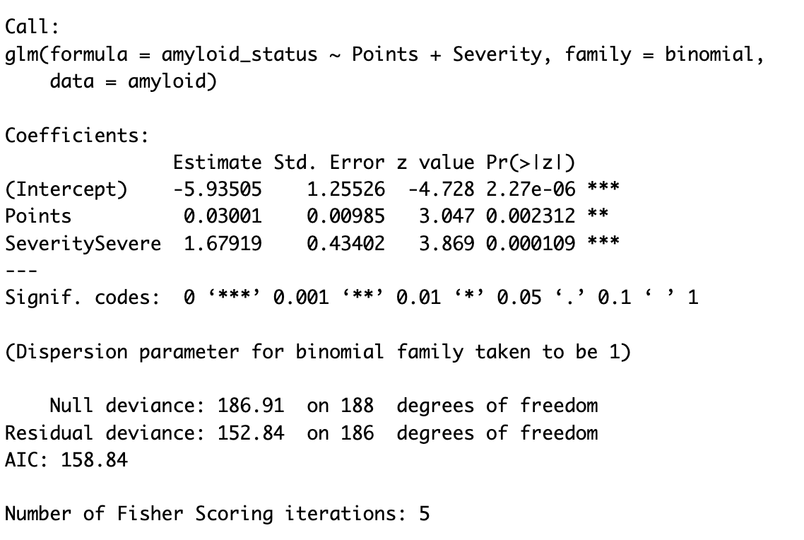

Intercept: When the nomogram point is 0 and the severity is mild, the log-odds of having amyloidosis is approximately -5.94.

Points: For every one-point increase in Nomogram points, the log-odd of having amyloidosis increases by approximately 0.03.

Severity: Patients with the severity level of severe have approximately 1.68 higher log-odds than the patients with the severity mild.

Model Summary for the Weighted Model for the Target Population:

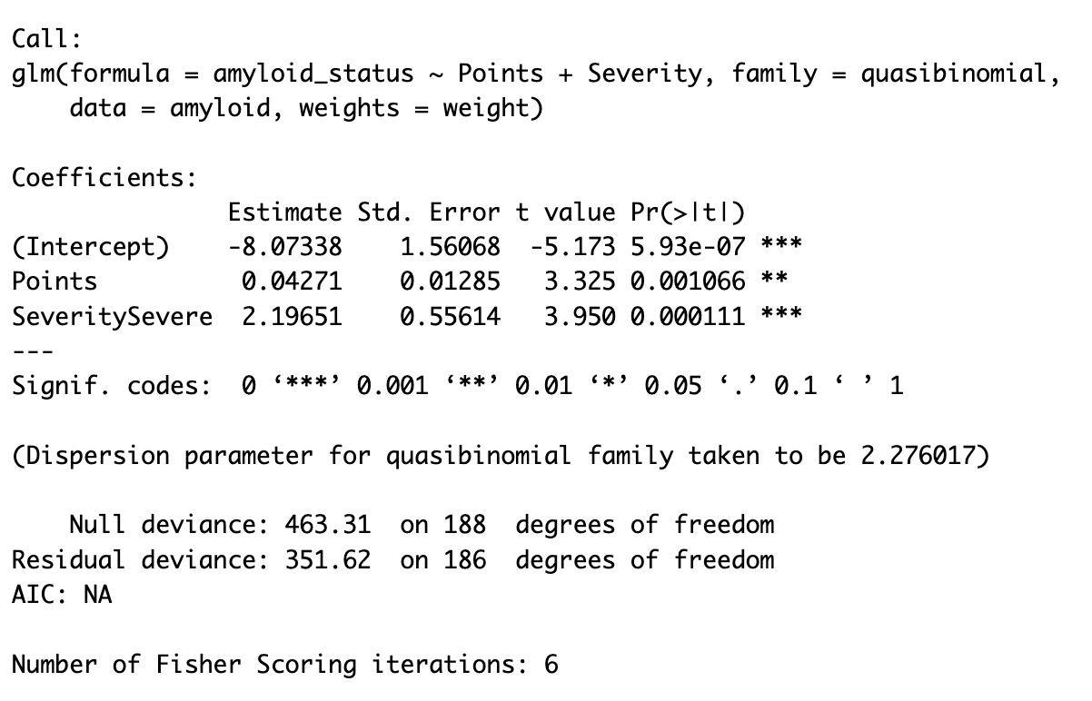

Intercept: When the nomogram point is 0 and the severity is mild, the log-odds of having amyloidosis is approximately -8.07.

Points: For every one-point increase in Nomogram points, the log-odd of having amyloidosis increases by approximately 0.04.

Severity: Patients with the severity level of severe have approximately 2.20 higher log-odds than the patients with the severity mild.

We can see that adjusting for sampling bias produces different inferences regarding the effect of Nomogram and severity on the probability of having amyloidosis. Severity has become a more important and stronger indicator of amyloidosis; nomogram score also increases in its importance of calculating the risk of amyloidosis.